Rest Step

Objective

A RESTAPI defines a set of functions which developers can perform requests and receive responses via HTTP protocol such as GET and POST etc.

In Rest step we are providing following Authorization types

Base OAuth

OAuth 1.0

UI

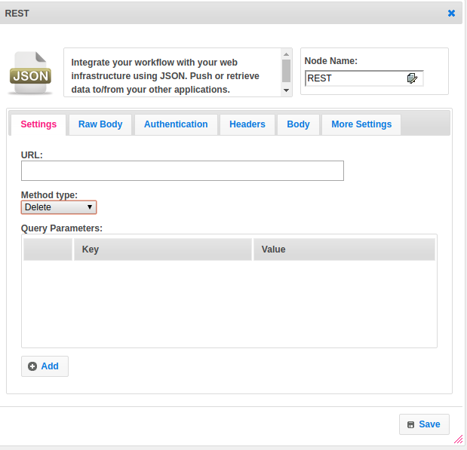

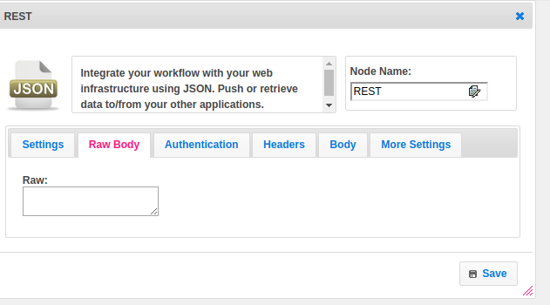

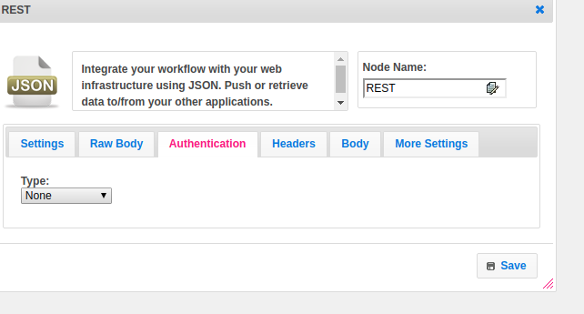

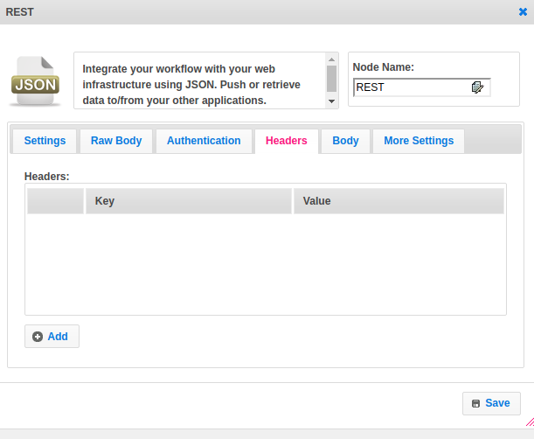

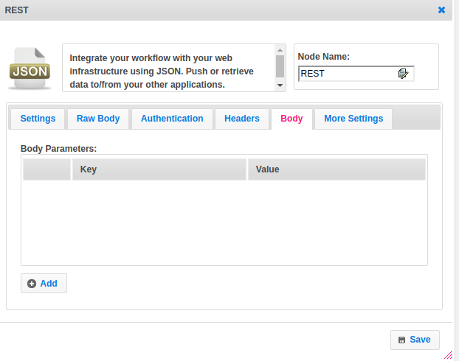

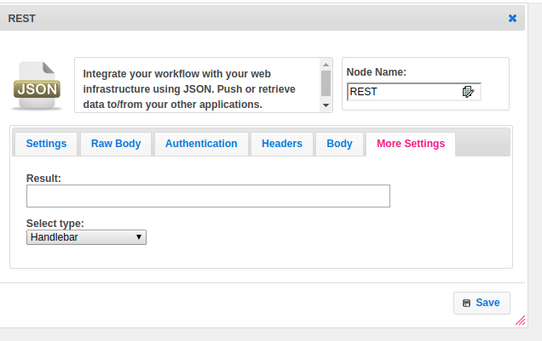

## Attributes

|  |  |
| --- | --- |
| **Attributes** | **Description** |
| **1. URL** | The URL is an essential part of a REST API. |
| **2. Method Type** | Following four HTTP methods are commonly used in REST-based architecture.  GET − Provides read-only access to a resource.  POST − Used to create a new resource.  DELETE − Used to remove a resource.  PUT − Used to update an existing resource or create a new resource. |
| **3.Query parameter** | The query parameter or query string is the part of a [uniform resource locator](https://en.wikipedia.org/wiki/Uniform_resource_locator) (URL) which assigns values to specified parameters. The query string commonly includes fields added to a base URL.  Provide the parameters in the form of a key-value pair. |
| **4.Raw** | Use the Raw tab to manually enter a request body. |
| **5.Authentication** | Authorization involves checking resources that the user is authorized to access or modify via defined roles or claims. For example, the authenticated user is authorized for reading access to a database but not allowed to modify it. The same can be applied to your API. Maybe most users can access certain resources or endpoints, but special admin users have privileged access.  Of course, these definitions are usually implemented together and interdependent, so when we refer to auth, we are referring to the overall system.  In Rest Step we have 2 types of authentications like Basic OAuth and OAuth 1.0. |
| **6.Headers** | Parameters included in the request header, usually related to authorization.  Provide the parameters in the form of a key-value pair. |
| **7. Body parameters** | Parameters included in the request body.  Provide the parameters in the form of a key-value pair. |
| **8. Result** | Used to store the response of the request. |

## Executor Description

Build the URL by using HttpUrl.Builder.Set the query parameters to URL if the request method type is GET. Add Headers given in the step. Add the form body. Set method type for a request. Execute the OkHttpClient new call. Get a response into the response object.

## Resource

Please refer the below link to get more details.

<https://dzone.com/articles/busy-developers-guide-restful>